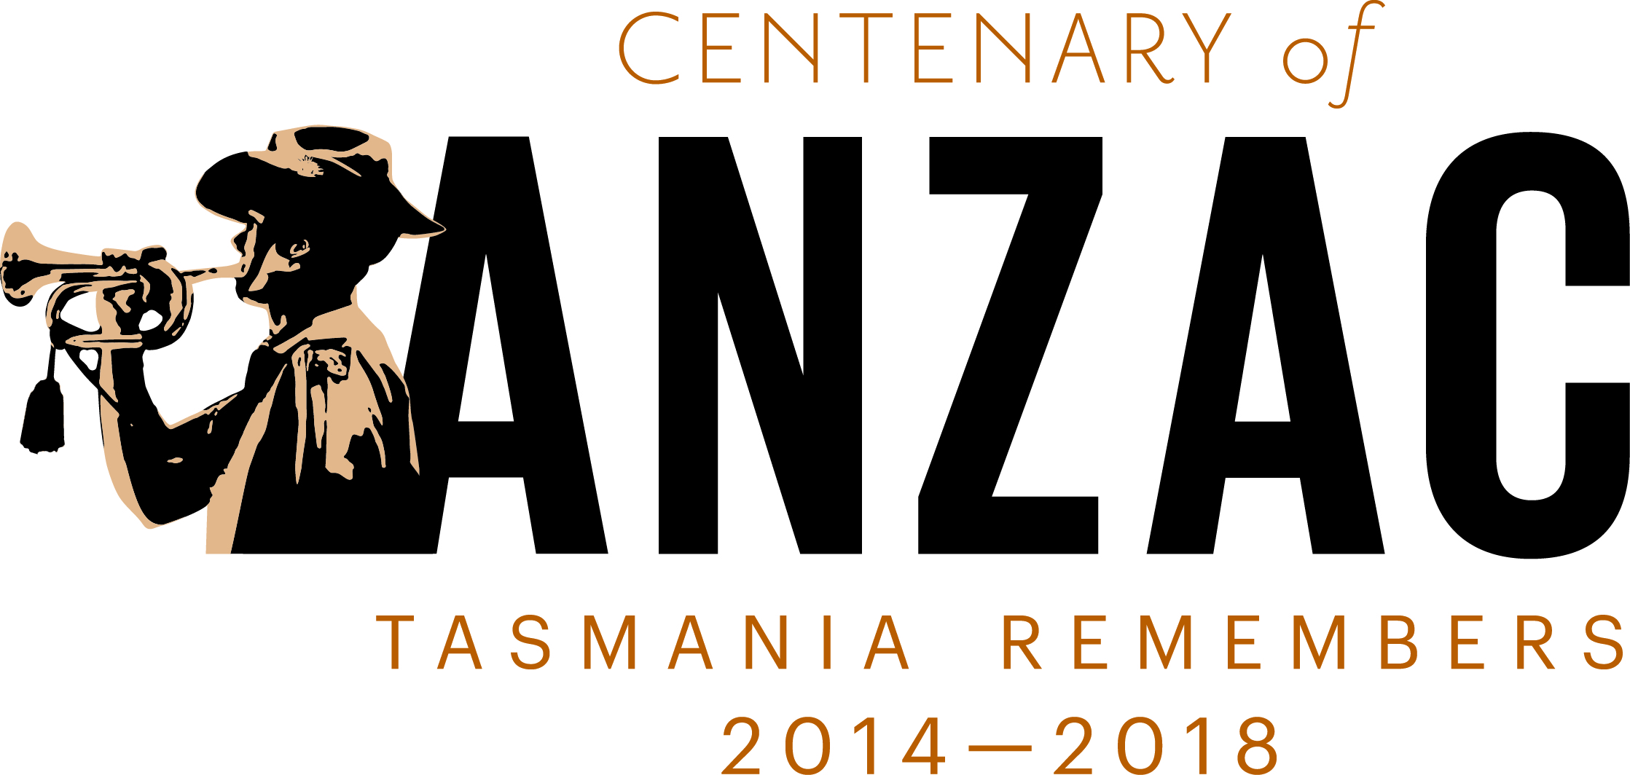

Centenary of ANZAC

Steering Committee

Communiqué
Centenary of ANZAC Steering Committee – 19 November 2014
The Centenary of ANZAC Steering Committee held a meeting at the RSL offices, ANZAC House, in New Town on 19 November 2014.
An update was given on the Centenary of ANZAC Public Fund run by the Commonwealth. On 11 November 2014 Senator Ronaldson announced that Tasmania will receive $1.1 million for the finalisation of Soldiers’ Memorial Avenue. The Department will work with the Commonwealth Government and Hobart City Council to facilitate this.
The following issues were discussed and considered:
- The $50 000 grant round of the Centenary of ANZAC Grant program opened on 13 September 2014 and closed on 24 October 2014. 27 applications totalling $117 364 were received with 14 being recommended for funding. The panel consisted of Mr Tony Scott OAM, Ms Sam Davis, Mr Nick Murnane (TVAC) and Mr Terry Roe (TVAC).

- ANZAC Day 2015. The Committee was given an updated on the schedule for ANZAC Day 2015. The commemoration will commence on 24 April 2015
with a Scout Vigil and Camp Gallipoli, which will be held at the old TCA Ground on the Domain. Camp Gallipoli will feature live and video entertainment, displays, an ANZAC Flame ceremony that will be held nation-wide and a sleep out. More information on Camp Gallipoli can be found at https://www.campgallipoli.com.au

The traditional Dawn Service will take place on Hobart’s Cenotaph with double the number of people predicted to attend. The community is being encouraged to attend Dawn Services in their local area and then make their way to the city for the 11.00 service. From there, a Community Gunfire Breakfast is being organised by the Greater Hobart RSL at Princes Wharf No. 1. ABC Radio will broadcast live from this event.

The Main Parade will commence at 11.00 am. At the conclusion of the Parade the official Flame of Remembrance dedication will occur on the Cenotaph prior to the Wreath Laying Service. It’s also anticipated that double the number of people will be attending this in 2015.

At the conclusion of the Wreath Laying Service a Coo-ee March will take place from the Cenotaph to the waterfront where 2500 poppies will be thrown into the River Derwent.
- With the website up and running there was discussion about how to communicate it to the public. The Committee encourages individuals and organisations to share stories and photos and provide details of commemorative events in their local area.

The next Steering Committee meeting is scheduled for March 2015.

