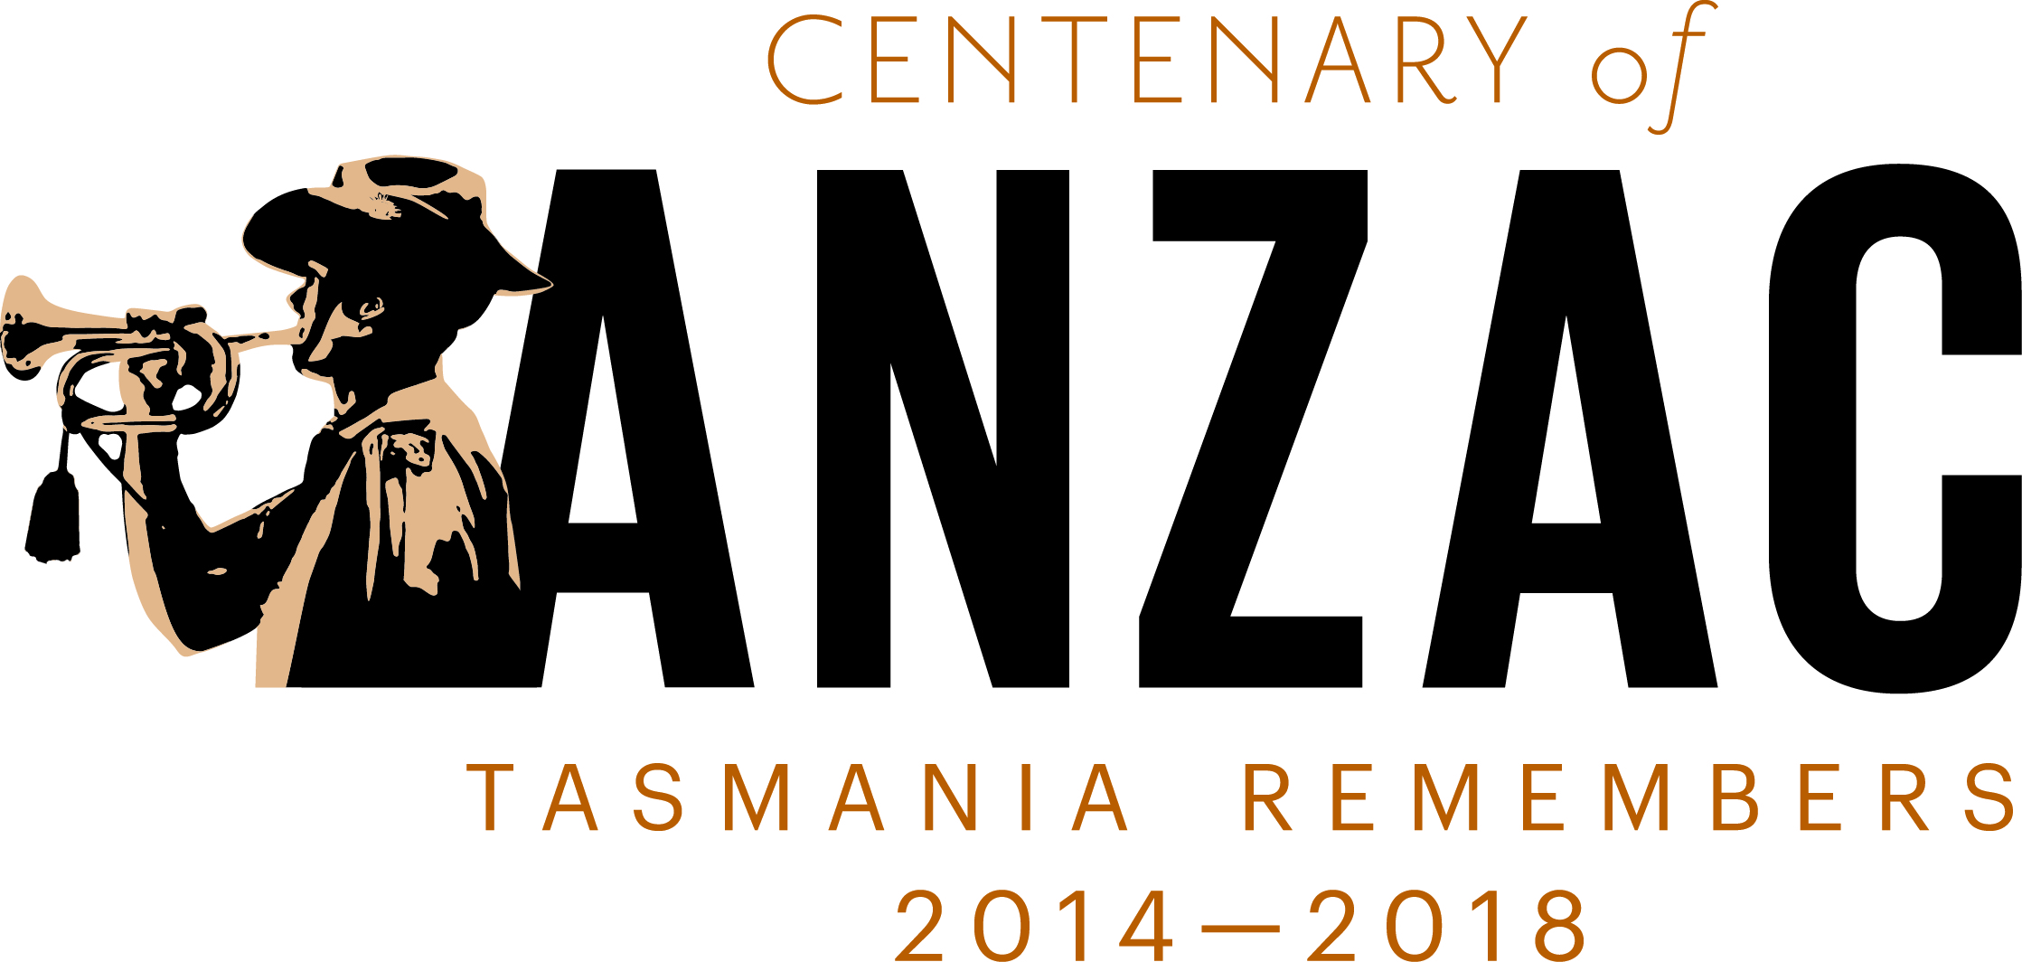

Centenary of ANZAC

Steering Committee

Communiqué
Centenary of ANZAC Steering Committee – 5 September 2014
The Centenary of ANZAC Steering Committee held a meeting at the Department of Premier and Cabinet offices in Hobart on 5 September 2014.
There was discussion about the Budget handed down by the State Government on 28 August 2014. While no funding allocation was made directly for the Centenary of ANZAC, it was confirmed that the Government’s commitments for Veterans’ Affairs were:
- Additional $100,000 funding to the RSL State Branch;
- Establishing the Teddy Sheean Memorial Grants Program to offer $100,000 each year for three years to fund minor capital works at ex-service clubs and organisations;
- Offering $100,000 in 2014-15 to assist in the maintenance and upgrade of Army, Navy and Air Force cadet infrastructure through the Cadet Infrastructure Grants Program;
- Providing $20,000 to RSL Tasmania to create a pilot program aimed at encouraging defence personnel to return to Tasmania when they discharge from the Australian Defence Force;
- Enabling the Claremont RSL to build a memorial at Windermere Bay with $45,000 in funding;
- Providing $230,000 to the Scottsdale RSL Military Museum to construct a museum to display an Iroquois helicopter from the Vietnam War; and
- Assisting the Cygnet RSL to upgrade its car park with $5,000 in funding.
The following issues were discussed and considered:
- Centenary of ANZAC Grants Program. The Committee reviewed the Guidelines for the next $50 000 program which is due to open on 13 September 2014 and close on 24 October 2014. Some minor changes to the priorities were made which will be available for viewing on 13 September 2014.
- Flame of Remembrance Project. On 1 August 2014 the Premier received confirmation from the Commonwealth Government that the Centenary of ANZAC Public Fund will grant Tasmania $300,000 for the construction of the Flame of Remembrance. The Cenotaph Reference Group, who is overseeing the project, is due to meet in mid-September to progress this development. The construction is due to be completed by ANZAC Day 2015, when the flame will be lit.
- ANZAC v Anzac. In recent months discussions have been held regarding the correct style of presenting the word ‘ANZAC’ – all capitals or with the first letter as a capital.
While it was noted that both styles were acceptable, the Committee unanimously voted that the preferred style was all capitals – ‘ANZAC’.
This means for the duration of the Centenary of ANZAC in Tasmania that all caps should be used.
- A Centenary of ANZAC website is progressing well with a launch date of Monday 29 September 2014 set. The URL will be www.centenaryofanzac.tas.gov.au
The website’s main features will be:
- an interactive timeline that shows significant dates in Tasmania’s and Australia’s history from wars, conflicts and peacekeeping operations since the Federation of Australia in 1901;
- a function to allow the sharing and publication of untold stories, never before seen photos and stowed away memorabilia that’s in the community;
- a calendar of events that will feature all government (local, state and Federal), and/or community sector events being held throughout the Centenary; and
- historical information about Tasmania’s rich military history and provide unique insights into the way war affected different members of the Tasmanian community.
- The Centenary of ANZAC launch featuring Tasmania’s 12th/40th Battalion exercising its Right to Freedom of Entry to the City of Hobart is scheduled for 18 October 2014.
The launch will feature the planting of a Lone Pine tree on Hobart’s Cenotaph to mark the occasion. It was raised that due to this, that Heritage Tasmania will need to be notified and give relevant approvals.

The next Steering Committee meeting is scheduled for 19 November 2014.

