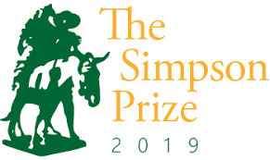

The Simpson Prize: A National History Competition for Year 9 and 10 students

The Simpson Prize is a national competition for Year 9 and 10 students. The competition encourages participants to explore the significance of the Anzac experience and what it has meant for Australia.
The student winner from each state and territory is awarded an overseas trip. Winners, along with runners-up and teacher chaperones, enjoy a two-day trip to Canberra.
The competition is funded by the Australian Government Department of Education and run by the History Teachers’ Association of Australia.
The student winner from each state and territory is awarded an overseas trip. Winners, along with runners-up and teacher chaperones, enjoy a two-day trip to Canberra.
2019 Simpson Prize Question:
To what extent could 1918 be considered a year of victory for Australia and its people?
The Simpson Prize requires students to respond to the question using both the Simpson Prize Australian War Memorial Source Selection and their own research.
Students are required to make effective use of a minimum of 3 of the Simpson Prize Australian War Memorial sources (which can be found at https://www.awm.gov.au/education/simpson-prize/).
It is also expected that up to half of their response will make use of information drawn from their own knowledge and research.

Word and Time Limits for Entries
Essay word limit: 1200-1500 words, not including supplementary information such as a contents page, references, bibliography and appendices.
Audio Visual Presentation word and time limit: No more than 10 minutes accompanied by a written explanation of up to 400 words.
Closing Date: Friday 9 November 2018.

The Prize: The student winner from each state and territory is awarded an overseas trip. In 2018, the winners went to the Western Front in Europe visiting tourist attractions and sites of historical significance in England, Belgium and France.
Winners, along with runners-up and teacher chaperones, enjoy a two-day trip to Canberra where they visit several of the capital’s museums and institutions, attend the presentation ceremony at Parliament House and enjoy a formal dinner at the Royal Military College, Duntroon.
Note: The winners of this year’s Simpson Prize will travel in 2019.
Tasmanian Results 2018:
Winner: Kate Sheahan, Deloraine High School
Runner-up: Caleb Paine, Rose Bay High School
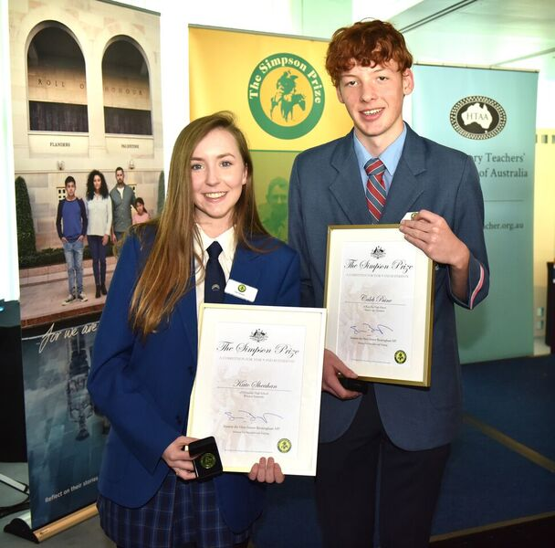
Information about the 2019 Simpson Prize: Essays produced by the state and territory winners of the 2018 Simpson Prize (and past results), along with relevant information regarding source materials, word or time limits, the closing date, entry forms and judging can be found on the following websites:
www.simpsonprize.org/
www.awm.gov.au/education/simpson-prize/
Contact Details:
Tasmanian History Teachers’ Association
c/o Rose Bay High School
Kaoota Rd,
Lindisfarne TAS 7015

Contact: Suzanne Pattinson
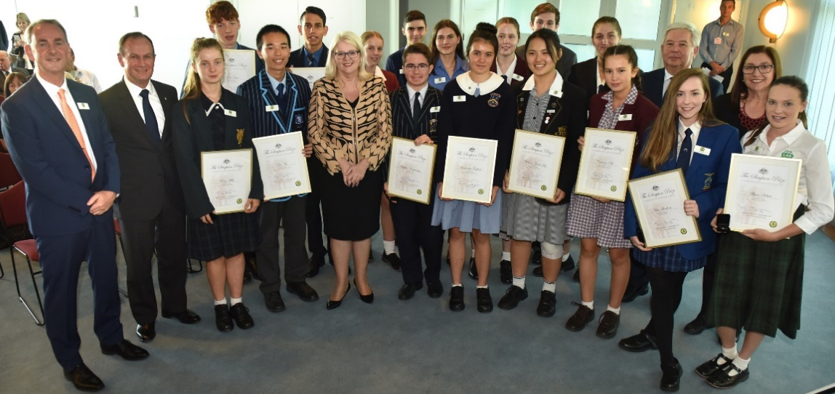
Tel: 03 6244 2544
Email: suzanne.pattinson@education.tas.gov.au

