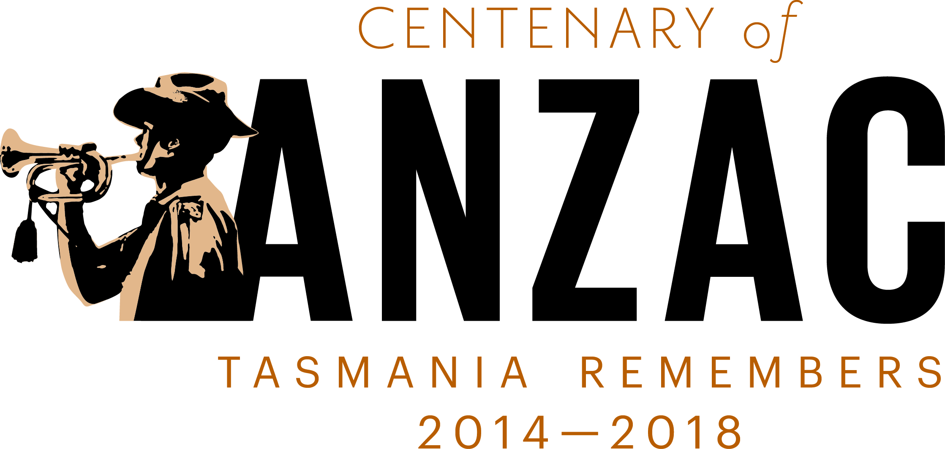

Centenary of ANZAC

Steering Committee

Communiqué
Centenary of ANZAC Steering Committee – 10 July 2014
The Centenary of ANZAC Steering Committee held a meeting at the Department of Premier and Cabinet offices in Hobart on 10 July 2014.
This was the first meeting with new members announced by Mr Guy Barnett MP, Parliamentary Secretary to the Premier, at Parliament House on Wednesday 25 June 2014.
It was confirmed that the Steering Committee’s role is to:
- be a central co-ordination and advisory group to government about the commemoration program;
- develop and implement a Centenary of ANZAC Commemoration Project Plan;
- provide direction and advice to the State Government and Community Working Group; and
- monitor expenditure.
The following issues were discussed and considered:
- Flame of Remembrance Project. The Tasmanian Government recently committed $200 000 to the construction costs of the Flame of Remembrance. The design of the Flame has been finalised and RSL Tasmanian has confirmed that the Flame will be completed and lit on ANZAC Day 2015.
- A Centenary of ANZAC website is currently under construction and due to be launched in September 2014. The website will feature a historical interactive timeline that people can explore. It will also give the Tasmanian community a place to promote their Centenary of ANZAC initiatives and events, as well as a place to share family war history stories. www.centenaryofanzac.tas.gov.au
- A Tasmanian Government Centenary of ANZAC brand has been developed which creates a unified visual symbol for government agencies, ex-service organisations, community groups and individuals to use when promoting Centenary commemorative initiatives and activities. The Steering Committee strongly encourages individuals and communities to use this brand. Further details can be found at www.centenaryofanzac.tas.gov.au or by phoning 6232 7090.
- The Tasmanian Government has been working with the Tasmanian Council of Churches on A Service marking the Declaration of the Centenary of The Great War. This Service is open to the public and will be held at St David’s Cathedral on Monday 4 August 2014 from 10.00am. Following the service, at 11.00am, the churches bells will be rung to promote remembrance of the significance of the day, 100 years ago.
- The Tasmanian Government is currently in the planning stages of its Centenary of ANZAC October Launch event. Further details will be discussed at the next Steering Committee meeting.
- The next round of the Centenary of ANZAC Grants Program is due to open in September 2014.

The next Steering Committee meeting is scheduled for 5 September 2014.

