Tasmanian Centenary of ANZAC logo guidelines

July 2014

Commemorating 100 years of service and sacrifice by Australian service-men and women in all wars, conflicts and peacekeeping operations since World War One.

The Tasmanian Centenary of ANZAC logo guidelines
These guidelines outline how the Tasmanian Centenary of ANZAC logo should be used to promote Centenary of ANZAC commemoration activities. Following these guidelines will ensure consistent and recognisable promotion of the Centenary of ANZAC in Tasmania across promotional materials for all commemoration activities.

The Tasmanian Government reserves the right to modify the guidelines or withdraw authorisation if an organisation does not comply with these guidelines at any time.

The Tasmanian Centenary of ANZAC logo
The Tasmanian Government has developed a logo that creates a unified visual symbol for State Government agencies, ex-service organisations and community groups in Tasmania to use when promoting Centenary commemoration activities.

The logo features a bugler. A bugle call was a tune played at the commencement and conclusion of each day during conflicts. It acted as a vital communication tool to pass instructions and information to officers and soldiers during battle. It also symbolises death, and the culmination of World War I.

Today, we are using the bugle to call Tasmanians together to commemorate the Centenary of WWI. These guidelines have been developed to ensure the logo creates a powerful legacy and tribute to the service and sacrifice of our past and current serving members.

Community use
The Tasmanian Centenary of ANZAC logo is the identifying symbol for the Tasmanian Centenary of ANZAC 2014-2018 Commemorative Program.

The Tasmanian Government encourages the community to use the branding for any non-commercial or non-profit purposes that commemorate the Centenary.

Individuals and/or organisations need to contact the Tasmanian Government for authorisation to use the logo (see application form at the end of these guidelines).

Authorisation to use the logo does not imply endorsement by the Tasmanian Government of the aims or opinions of individuals and/or organisations.

Any organisation that has received funding from the Tasmanian Government to hold Centenary of ANZAC-related events or activities will be required to use the logo (see acknowledging Tasmanian Government support section of these guidelines.)

Logo versions
There are two versions of the Tasmanian Centenary of ANZAC logo: the full-colour and the mono version.

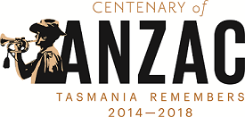

Full colour logo
The preferred version is the full-colour version of the Tasmanian Centenary logo.

Mono logo
The mono version is only to be used in circumstances where the full-colour version is not practical i.e. In a black and white publication or if the full-colour version will not achieve sufficient contrast for legibility.

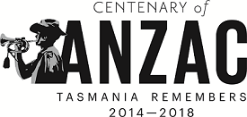

Merchandising
The logo is for non-commercial purposes only and any use of the logo for commercial gain is strictly prohibited.

Correct use of the logo

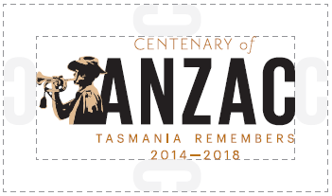

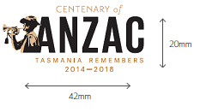

Clear space around the logo
A clear space must be defined around the logo to ensure it is not overwhelmed by other associated symbols or graphic elements. The minimum required space on all sides is measured by the letter C in the word ANZAC as demonstrated.

Minimum size
The minimum size for reproduction of the logo is 42mm wide and 20mm high.

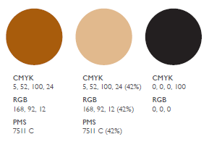
Colours
The Centenary of ANZAC branding comprises the following colours:

Tasmanian Government use of the Tasmanian Centenary of ANZAC logo
Tasmanian Government agencies are to use the Tasmanian Centenary of ANZAC logo as a ‘graphic device’.

Under the Tasmanian Government Style Guide and Logo Policy, a graphic device is an illustration or graphic developed to represent a program or initiative, in this case, the Centenary of ANZAC. The logo must be used within the Tasmanian Government design framework, which also includes mandatory elements such as font, colours and a basewave device. Graphic devices such as the Tasmanian Centenary of ANZAC logo can be included in the general area of a design above the basewave; they may not be placed below the basewave.

For further information on how to use the Tasmanian Centenary of ANZAC logo in conjunction with Tasmanian Government branding, please visit www.communications.tas.gov.au

Acknowledging Tasmanian Government funding support
The Tasmanian Government is working with and supporting individuals and/or organisations running Centenary of ANZAC initiatives and events. The Tasmanian Government needs to be acknowledged where it has a formal agreement to endorse, fund or provide in-kind support for an initiative or event.

A ‘supported by’ version of the Tasmanian Government logo will be provided to organisations that receive funding support from the Tasmanian Government. The supported by logo is used specifically to recognise the funding support by the Tasmanian Government. The ‘supported by’ logo must always be at least 20mm wide. The ‘supported by’ logo may be placed alongside other supporter/sponsor logos.

The Tasmanian Centenary of ANZAC logo has been created to promote the Tasmanian Centenary of ANZAC so you are encouraged to display it prominently on your promotional material. It should not be positioned next to the ‘supported by’ Tasmanian Government logo and other organisational logos.

Improper use
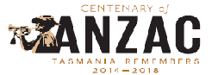
Do not stretch or distort the logo.

Do not separate remove elements (i.e remove taglines)

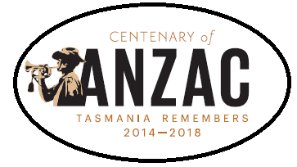

Do not place the logo in a shape

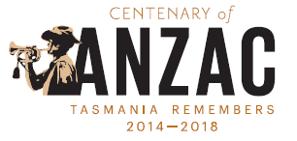
Do not rotate the logo

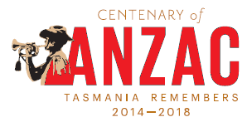
Do not change the logo colour

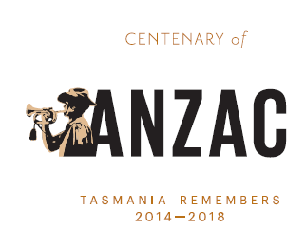

Do not separate branding elements

